Ideation Phase
Brainstorm & Idea Prioritization Template

Date | 14 July 2026
Team ID | Individual Project
Project Name | Library Book Request Management System
Maximum Marks | 4 Marks

Brainstorm & Idea Prioritization :
The brainstorming phase is the first step in identifying and selecting a meaningful project idea. The objective was to analyze real-world problems faced by students in educational institutions and identify a solution that could be effectively implemented using the ServiceNow platform.
Several project ideas were considered and evaluated based on factors such as user impact, implementation feasibility, automation capability, ease of use, and future scalability. After comparing multiple ideas, the Library Book Request Management System was selected because it addresses a common issue in college libraries by replacing manual book request procedures with a digital workflow.
The selected solution enables students to submit book requests online, allows librarians to approve or reject requests efficiently, maintains request records, and improves transparency throughout the request process.
Reference: https://www.mural.co/templates/brainstorm-and-idea-prioritization
Step-1: Problem Identification and Idea Selection
Section 1 : Problem Identification
During the brainstorming process, common problems experienced by students in college environments were identified. Existing manual processes in libraries were analyzed to determine areas where automation could improve efficiency and user experience.

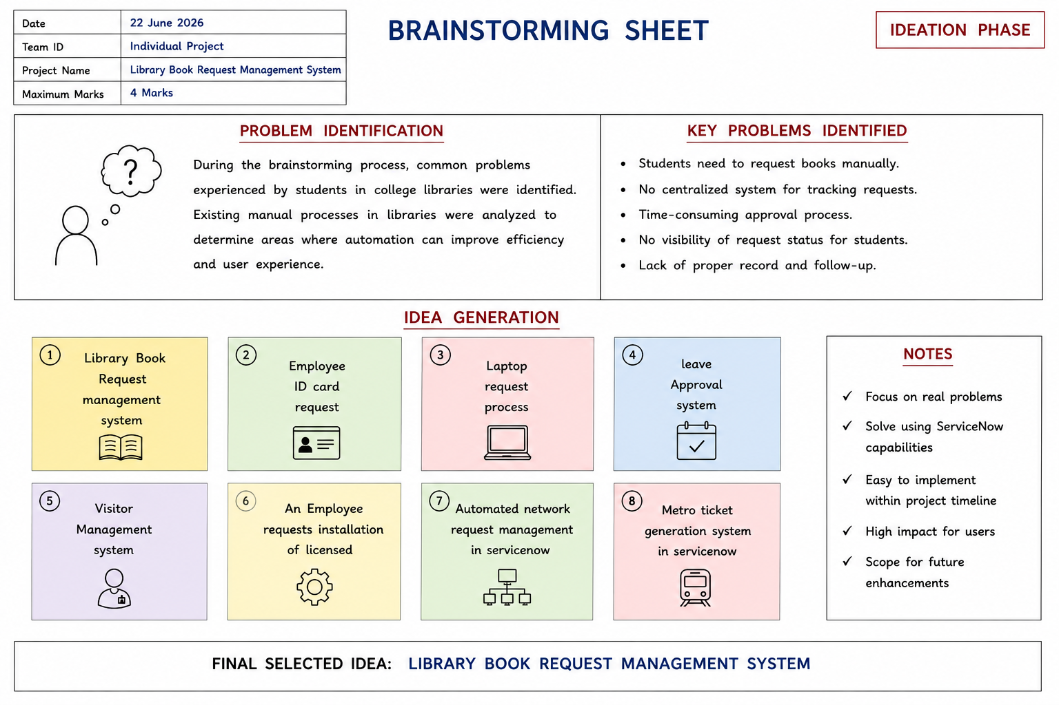

Section 2 : Idea Generation
The following project ideas were generated during the brainstorming process:
Sl No | Proposed Idea
1 | Library Book Request management system
2 | employee ID card request
3 | laptop request process
4 | leave approval system
5 | visitor management system
6 | metro ticket generation system in servicenow
7 | An Employee requests installation of licensed
Section 3 : Idea Evaluation
Among all the proposed ideas, the Library Book Request Management System achieved the highest overall score because it solves a real-world problem, supports workflow automation, and can be efficiently implemented using ServiceNow's forms, tables, Flow Designer, and notification features.
Criteria | Library Book Request
User Impact | ⭐⭐⭐⭐⭐
Feasibility | ⭐⭐⭐⭐⭐
Automation Scope | ⭐⭐⭐⭐⭐
ServiceNow Compatibility | ⭐⭐⭐⭐⭐
Ease of Development | ⭐⭐⭐⭐
Innovation | ⭐⭐⭐⭐

Step-2: Brainstorm, Idea Listing and Grouping

Idea Generation
During the brainstorming phase, multiple project ideas were identified based on common business and educational workflow automation requirements. The following ideas were considered:
Sl.No | Project Idea
1 | Library Book Request Management System
2 | Employee ID Card Request
3 | Laptop Request Process
4 | Leave Approval System
5 | Visitor Management System
6 | Employee Licensed Software Installation Request
7 | Automated Network Request Management in ServiceNow
8 | Metro Ticket Generation System in ServiceNow

Idea Grouping
The identified ideas were grouped based on their functional domain to simplify evaluation.
Category | Project Ideas
Library Services | Library Book Request Management System
HR Services | Employee ID Card Request, Leave Approval System
IT Services | Laptop Request Process, Licensed Software Installation Request, Automated Network Request Management
Administration | Visitor Management System
Public Services | Metro Ticket Generation System

Step-3: Idea Prioritization

Idea Evaluation Criteria
Each project idea was evaluated using the following criteria:
- User Impact
- Feasibility
- ServiceNow Compatibility
- Ease of Development
- Innovation

